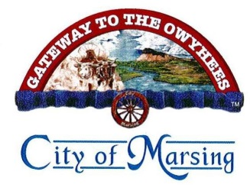
City of Marsing
City Clerk
18 Sandbar AVE
PO Box 125
Marsing, ID 83639
208-896-4122 (O)
208-896-4123 (F)

Public Records Request
The City of Marsing complies with the Idaho Public Records Act (Idaho Code § 9 – 338) for the public to examine and/or copy the following records. This request pertains to existing documents only. The City agrees to respond and deliver the requested records within three (3) days, but if necessary may, with written notification, take up to ten (10) days. By law, information gained through this request cannot be used for the purpose of compiling a mailing list or telephone list without obtaining permission from each individual.

Name |  | Time | Date
Street Address |  | Phone
City, State |  | Fax
Signature |  | Email
Information Requested: (Be as specific as possible)
I request to examine [ ] or copy [ ] the following records (must be specific records - name, date, or range of dates of document(s) you are requesting)

Delivery of copies are to be Hard [ ] or Electronic [ ]
Results/Findings – Staff Use only:

Staff providing information | Comments
Email completed requests to office@marsingcity.com

